Banking Catalog Pricing Sample Readme
This ruleset was developed for a banking demo featuring InfoSphere MDM and IBM ODM.
Download and install
This project be downloaded individually. Import the project into Rule Designer:
Click File > Import > Expand General > Select Existing Projects into Workspace, and click Next. Browse to the downloaded project.

The purpose of the decision service is to determine the price of a banking product bundle (as an aggregation of individual products). Input parameters are all based in XML Schemas, so the resulting decision service can be easily be called as a HTDS. This is the XOM being used by the rules:
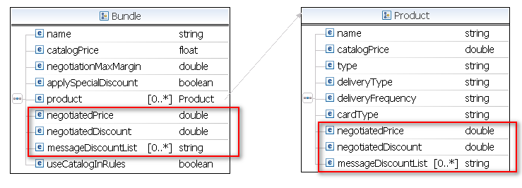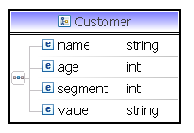
The same Schema is being used for input and output of the rules (in red the output).
The overall process is as follows:
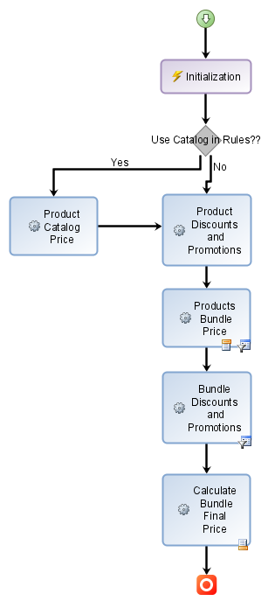
- In the specification of the demo the data "Product.catalogPrice" is an input for the rules because this data was maintained in MDM tables. To make the decision service self-contained I added the catalog price as a table inside the ruleset (see "Product Price.Catalog Price.Product Catalog Price Table"). You can control if this pricing table should be executed or not using the extra input data "Bundle.useCatalogInRules". If false, the table will not be considered in the rule execution and so, the catalog price is supposed to be given as input.
- So, the first conditional step is to determine the catalog product of the individual products of the bundle.
- Next is to apply specific promotions/discount that could apply to individual products of the bundle (see "Product Price.Discount and Promotions").
- Next, the product of each individual product is recomputed depending on the bundle where it is packaged. All that pricing rules for all the different bundles are contained in the same package "Bundle Price.Products in Bundle Price". So the ruleflow does a dynamic selection of the rules to be applied depending on the actual bundle provided as input parameter. The selection is made based on the documentation of the rule that should contain the specific comment "BUNDLE_ID=<name of the bundle>". This trick is to avoid complicating the demo adding additional properties to the rules, like it should be in a real case. You can see dynamic selection of ruletask "Products Bundle Price" or "Bundle Discounts and Promotions" or "Calculate Bundle Final Price"
- Next, discount and promotions for the global bundle are applied (same dynamic rule selection pattern).
- Finally the final price for the bundle is calculated.
History changes
Version: 8.7.0 (Feb 19, 2015)
. migrated to 8.7 and new Decision Service
. removed xls format scenario
Version: 8.0.0 (July 19, 2012)
. migration to WODM 8
. duplicate xls scenario to have a 2010 version (.xlsx)
. ignore messageDiscountList for DVS to remove warning messages when running tests
Version: 7.5.0.1 (April 2, 2012)
. deleted spanish reglas.txt in doc
. deleted wsdl folder under xml/
Version: 7.1.1.1 (Dec 21, 2010)

